All Business Summary March 2001 (February Production)

Settlements Headcount Versus Plan

Staffing Headlines – March

- Anna McAndrew (Snr Director) joined replacing Ian Sloman as Head of Settlements, reporting to Mike Jordan.
- Ian Sloman moved to a new opportunity in MO Technology as a business liaison.
- Adrian Hendrick (Specialist) joined as supervisor to the UK team, reporting to Gill Denham.
- Caroline Arlott (Admin) joined the UK team and Jorg Wiener (Admin) joined the Continental team.
- Simon Foster and Shahab Isaac joined as temporary resources.
- Amit Sinha & Chris Rowe moved to Contract Management as part of the migration of Role & Responsibilities.
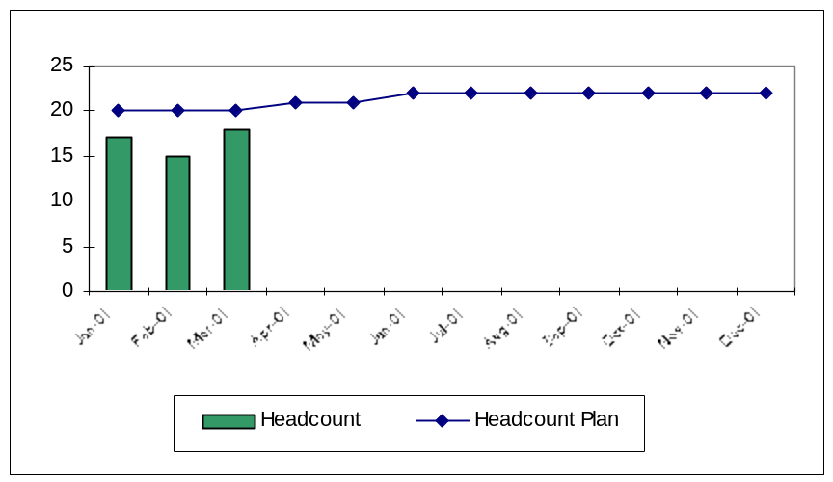

Recruitment, Retention, Attrition & Experience Statistics *

 | Jan | Feb | Mar | Apr | May | Jun | Jul | Aug | Sep | Oct | Nov | Dec
Initial Headcount | 17 | 17 | 15
Leavers – Enron Commercial |  | (1)
Leavers – Enron non-Commercial |  |  | (3)
Leavers – Management initiated |  | (2)
Leavers – Voluntary other
New Joiners – from within Enron
New Joiners – external new hires |  | 1 | 4
Temporary Staff |  |  | 2
Final Headcount | 17 | 15 | 18
Average Experience (months) | 9.7 | 10.8 | 8.4

Volume Statistics

Other Headlines – March

 | Feb | Mar
Avg Hours Overtime | n/a | 34 | ■ Y
# Counterparties | tbd | tbd | ■ B
Settlement error rate | tbd | tbd | ■ B
Attrition | 18% | 20% | ■ Y
Avg Experience (mo) | 10.8 | 8.4 | ■ R

Trigger Levels
 | ■ R | ■ Y | ■ G
Overtime | >40 | >20 | <=20
# Counterparties | tbd | tbd | tbd
Error rate | tbd | tbd | tbd
Attrition | >20% | >10% | <=10%
Avg Experience | <10 | <12 | >=12

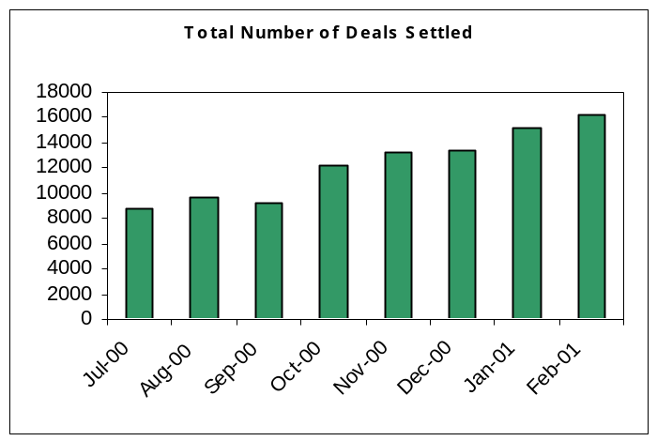

2001 Project status & Commentary

Structured deal handover to CM | ■ | UK Gas completed. UK Power & Cont Gas ongoing. R&Rs to be documented..
Accrual / Credit Process | ■ | Not yet started – awaiting Trade Accounting resources.
Daily Settlements team set-up | ■ | Awaiting additional resources
EnVoice Implementation | ■ | Implementation delayed as UAT not yet signed-off.
Collateral review | ■ | Not yet started – planned for April
VAT Re-engineering | ■ | Not yet started

UK Gas March 2001 (February Production)

Volumes / Error Information

 | Physical | Structured | Options | Financial | Brokerage
Total Number of Settled Deals | 4770 | 17 | 160 | 136 | *
Settlements errors | 5 | 0 | 0 | 0 | *
Other errors/issues | 11 | 0 | 0 | 0 | *
Settlement error rate | 0.1% | 0.0% | 0.0% | 0.0% | *
Interest Claims against Enron ($ amount) | 0 | 0 | 0 | 0 | 0
Interest Claims by Enron | 0 | 0 | 0 | 0 | 0
Manual Payments | 2 | 0 | 0 | 0 | 0

Commentary – Errors/Issues

No | Type | Commentary | Counterparty
1 | Settlements | Failure of manual controls – non-release of payment from SAP. Payment made two days late. Counterparty has not claimed any interest. | Amerada Hess
4 | Settlements | EnBank invoices sent with incorrect volumes. | Enbank customers
10 | Commercial | Deal not captured in Gas Desk accurately or completely. | Various
1 | Client | CP netted UK Gas Payment when no netting doc had been received | Soc Gen

Commentary – Manual Payments

No | Cause | Commentary | Counterparty
1 | System | LOM-SAP interface failed. | Innogy
1 | System | Exchange daily reconciliation often prevents timely push through systems. | Carr Futures

Volume Trends
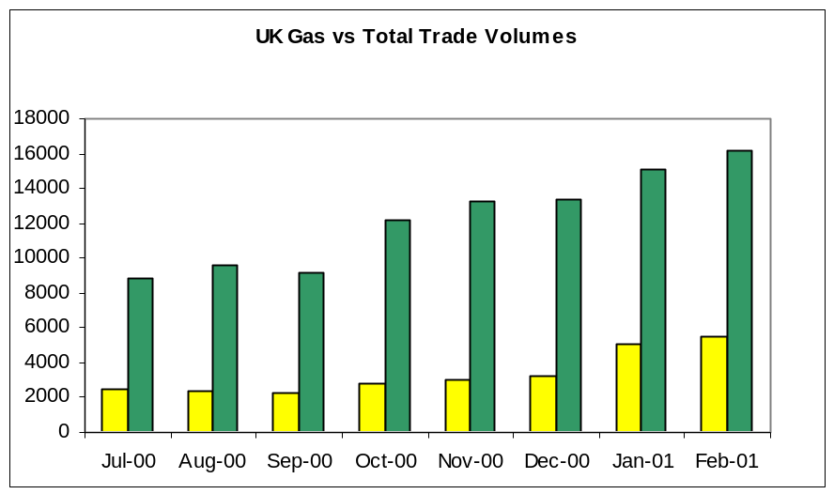

Management Highlights

- Envoice: Several issues continue to be resolved before UAT is signed off. Testing by Settlements staff continues.
- Clients: Two counterparties were called by Cash Clearing team attempting to recover outstanding funds. The funds were under legitimate dispute by these counterparties and client queries were susequently received by Settlements. Settlements/Cash Clearing to agree a revised process.
- Structured Deals: Settlements & Contract Management have agreed a handover of staff & responsibility to provide liquidating values for the industrial deals. Amit Sinha (on secondment to Settlements will move to Contract Management with immediate effect).
UK Power- March 2001 (February Production)

Volumes / Error Information

 | EFA | Structured | Options | Brokerage
Total Number of Settled Deals | 2946 | 5 | 4 | *
Settlement errors | 1 | 0 | 0 | *
Other errors/issues | See below | 0 | 0 | *
Settlement error rate | 0.3% | 0% | 0% | *
Interest Claims against Enron ($ amount) | 0 | 0 | 0 | 0
Interest Claims by Enron | 0 | 0 | 0 | 0
Manual Payments | 0 | 0 | 0 | 0

Commentary – Errors/Issues

No | Type | Commentary | Counterparty
1 | Settlements | 444 settlement was not picked up, payment was 2 days late. | Magnox
2 | Risk/Docs | * A number of deals were booked with incorrect settlement frequencies in EnPower. | Various
3 | IT | * Re-scheduling efforts significantly decrease the amount of time Settlements can spend resolving issues with CPs and increase the time taken to reconcile EnPower to BOSS before invoices can go out. | Various

Commentary – Manual Payments

No | Cause | Commentary | Counterparty
1 | Settlements | Payment not released in time for interface to TWS. | Magnox

Volume Trends
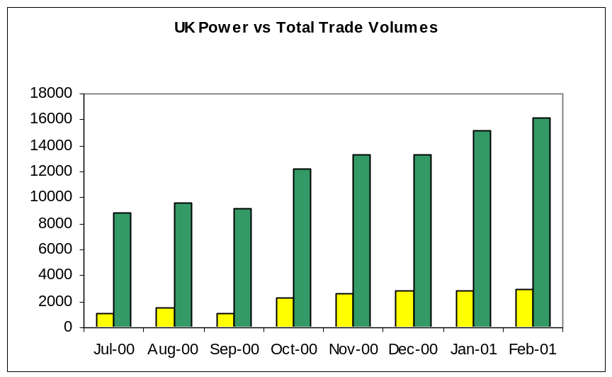

Management Highlights

- NETA: Settlements continue to work on procedures, systems and processes for the onset of NETA. New invoicing systems are being developed by the Back Office IT Support team: a new BOSS for GTMA & Schedule 5 invoicing and the BATS system for settling the daily balancing charges. Settlements await UAT.
- Structured Deals: Settlements & Contract Management have agreed in principle the handover of responsibility for liquidating structured deals for settlement purposes. The handover will include the transfer of 2 settlements headcount TBA. Handover in UK Power will consider the added impact of NETA changes – a longer handover period is expected.
- Staffing Issues: Solomon Hammond has been released from Enron in his probation period and Ray Dollman has been moved to Systems Liaison role. Sandra Butcher and Fiona Islam will be responsible for UK Power settlements with recruitment continuing for additional staff.
Continental Gas- March 2001 (February Production)

Volumes / Error Information

 | Physical | Options | Financial | Brokerage
Total Number of Settled Deals | 720 | 0 | 0 | *
Settlement errors | 1 | 0 | 0 | *
Other Error/Issues | 5 | 0 | 0 | *
Error rate | 0.14% | 0.0% | 0.0% | *
Interest Claims against Enron ($ amount) | 0 | 0 | 0 | 0
Interest Claims by Enron | 0 | 0 | 0 | 0
Manual Payments | 2 | 0 | 0 | 0

Commentary – Errors

No | Type | Commentary | Counterparty
5 | Risk | Incorrect prices on invoices. | Various

Commentary – Manual Payments

No | Cause | Commentary | Counterparty
2 | System | LOM – SAP interface failure. | Rhurgas/Distrigas

Volume Trends
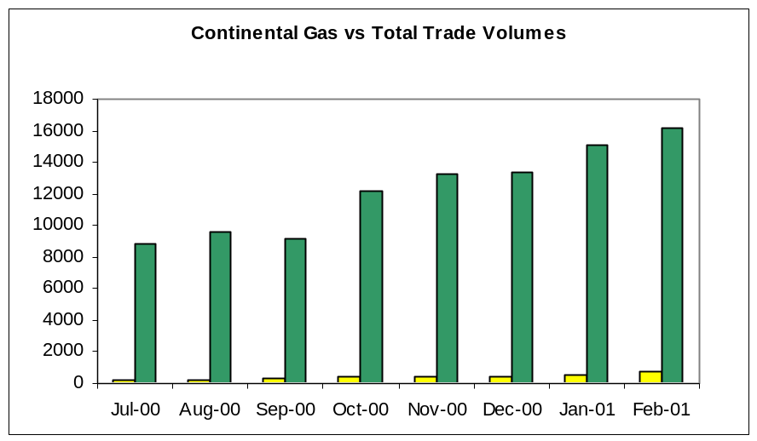

Management Highlights

- Structured Deals: Any trade structures that cannot be accurately reflected in the current version of GasDesk or where there is no autmated liquidation calculation are in the process of being migrated to the Contract Management team. Headcount has been transferred to cover this role.
- Entrade deals: Entrade deals have not been settled as they have been invoiced from Essent even though the trades have yet to be novated. Commercial are aware & in communication with client.
- Process Review: gas transportation invoice validation process underway in order that a less manual and less time consuming process could be implemented.
- EnVoice: extensive EnVoice testing by Settlements users. UAT has not been signed off and implementation is to be delayed.
- Review of CP static data: underway to ensure data integrity & completeness for EnVoice implementation. Address, VAT number, bank details etc to be validated.

Continental Power- March 2001 (February Production )

Volumes / Error Information

 | Physical | Options | Financial | Brokerage
Total Number of Settled Deals | 6843 | 25 | 136 | *
Settlement errors | 3 | 0 | 0 | *
Other errors/issues | 1 | 0 | 0 | *
Error rate | 0.4% | 0.0% | 0.0% | *
Interest Claims against Enron ($ amount) | 0 | 0 | 0 | 0
Interest Claims by Enron | 0 | 0 | 0 | 0
Manual Payments | 7 | 0 | 0 | 0

Commentary – Errors

No | Type | Commentary | Counterparty
3 | Settlements | Incorrect VAT on physical invoices. | Eon
1 | Commercial | Incorrect volume | unknown

Commentary – Manual Payments

No | Cause | Commentary | Counterparty
7 | Systems | Payments cannot be made through SAP. | EEX

Volume Trends
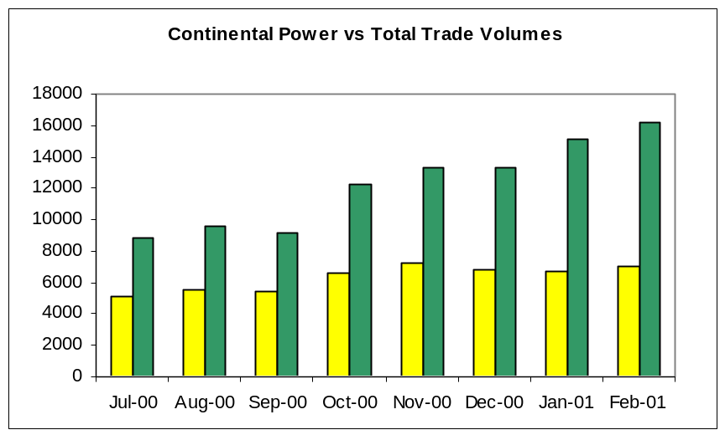

Management Highlights

- Collateral procedure review: process reviewed across all Exchanges after Enron were incorrectly suspended from trading on APX. Daily control process implemented and bank guarantee set-up.
- Brokerage back-log: Cash Clearing team handed back responsibility for Brokerage with a large back log. One temporary member of staff has been employed to clear Continental Power back log.
- Staffing: Jorg Weiner has been recruited to replace Andreas Schober, who left Settlements to join the Continental Power Commercial team.

